CSA1103 00AD-LAB PRACTICE P.Lakshmi Gayathri Navaneetha(192321169)
Question 6: Food Delivery Application – Communication Diagram
Scenario:
A food delivery application connects customers, restaurants, delivery partners, and payment
services. Customers place food orders through the mobile application. Restaurants accept and
prepare the orders. Delivery agents receive delivery requests and pick up the prepared food.
Online payment confirmation is received before delivery. Customers can track delivery in real
time. Restaurants update order preparation status regularly. Delivery partners notify customers
upon arrival. Customer feedback is collected after successful delivery. The company wants to
visualize object communication.
USECASE DIGRAM:
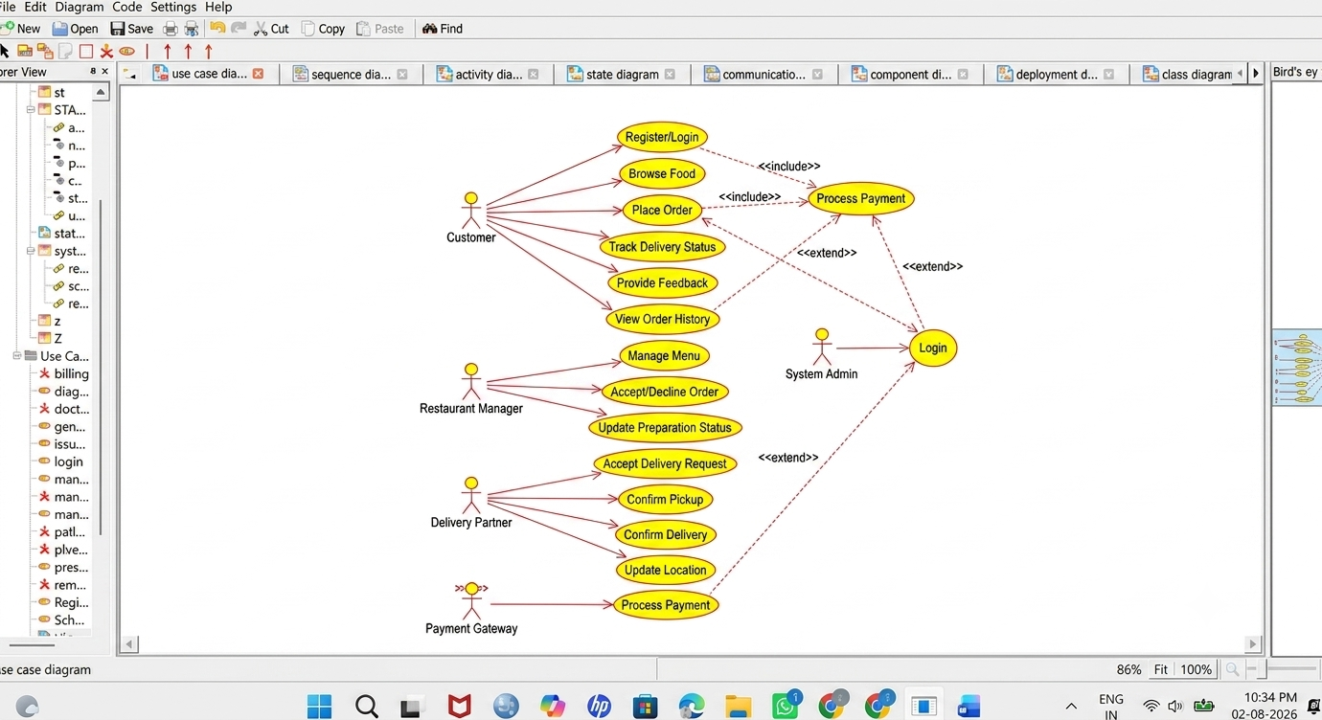

CLASS DIAGRAM:
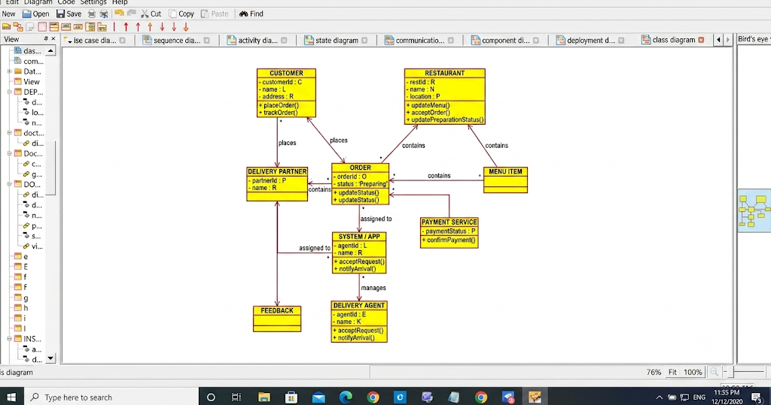
ACTIVITY DIAGRAM:
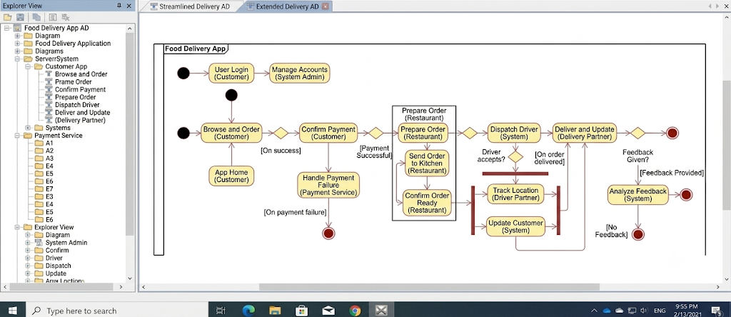

DEPLOYMENT DIAGRAM:
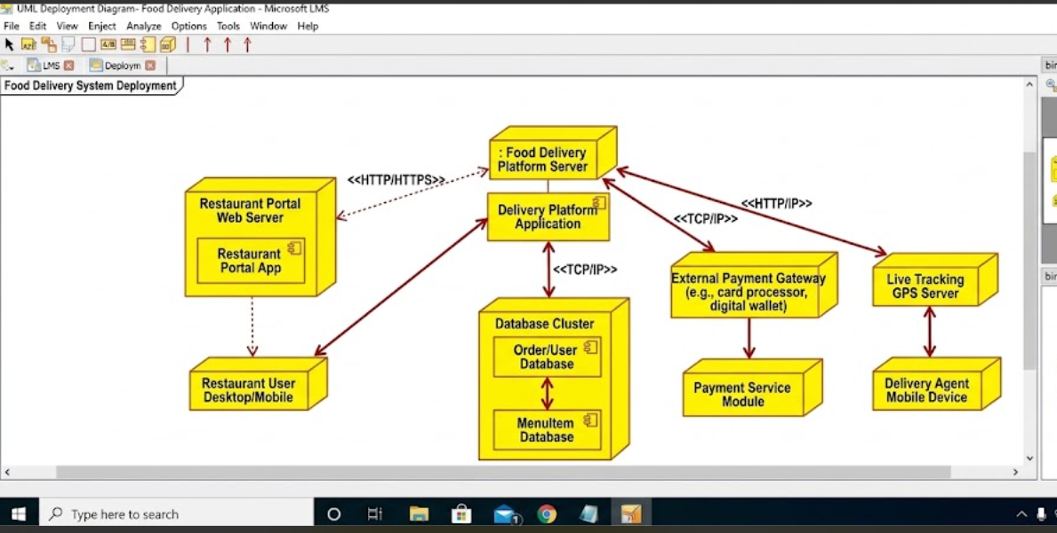
SEQUENCE DIAGRAM:
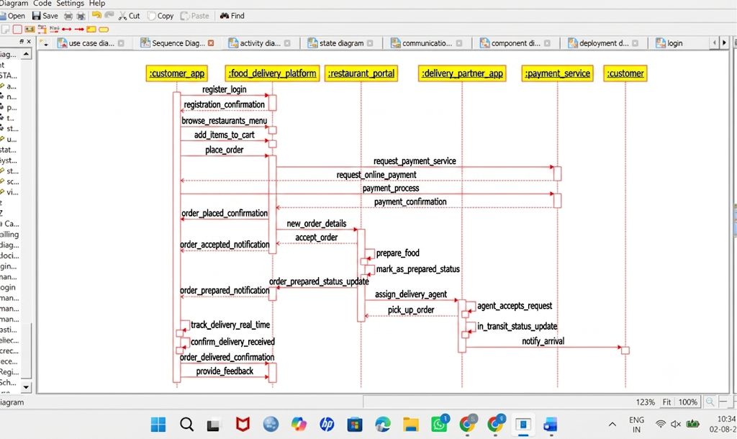

STATE MACHINE DIAGRAM:
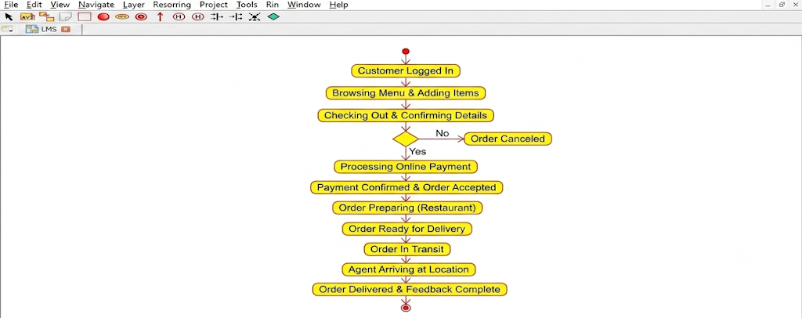
COMPONENT DIAGRAM:
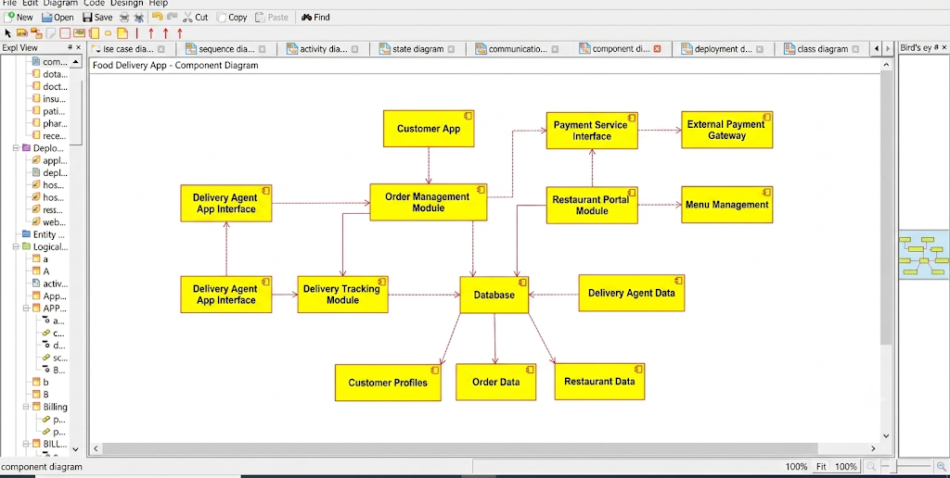

COMMUNICATION DIAGRAM:
